Joaquin Salas
UIN: 731000141
ECEN 325 – 512 Prelab 1
8/30/23

Part 1 – Calculations

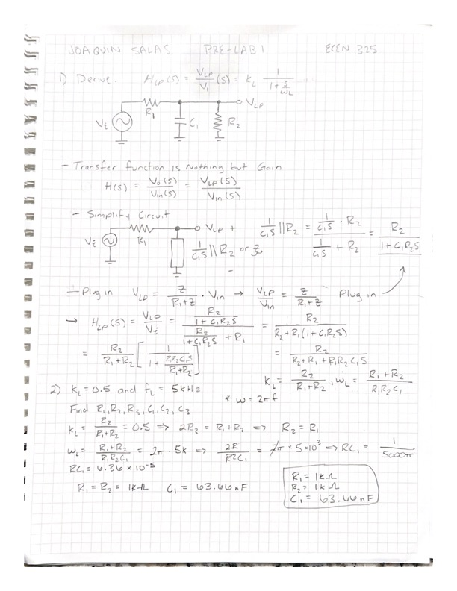

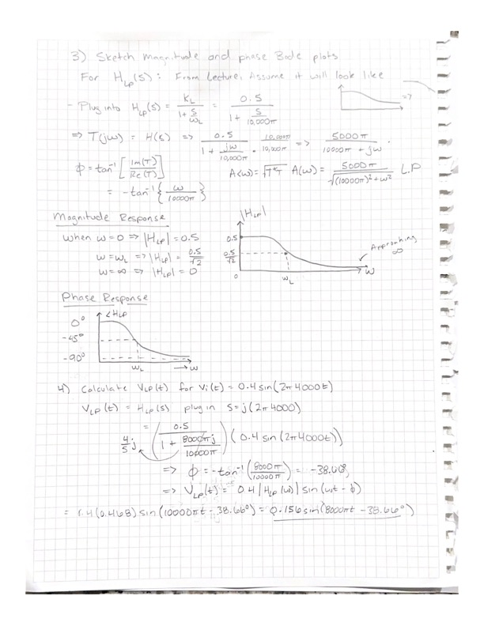

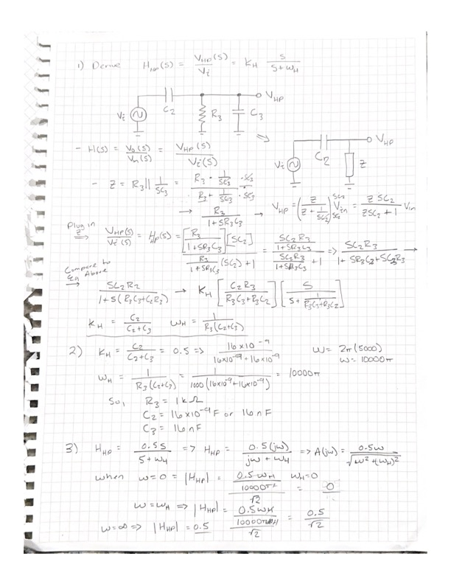

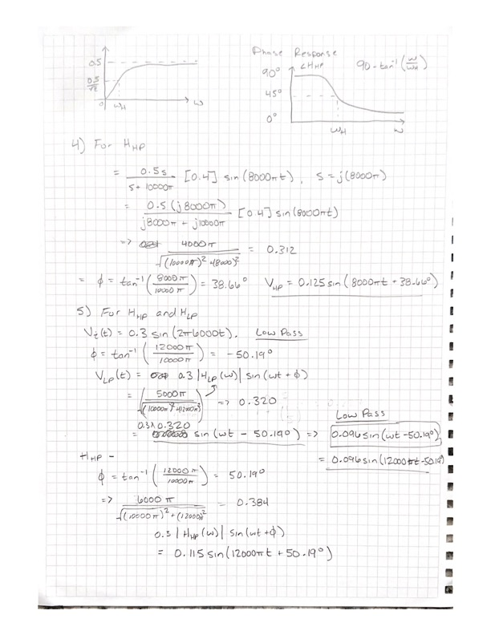

Part 2: Simulations

- Low Pass Filter Bode Plot at 4kHz and 4mV.

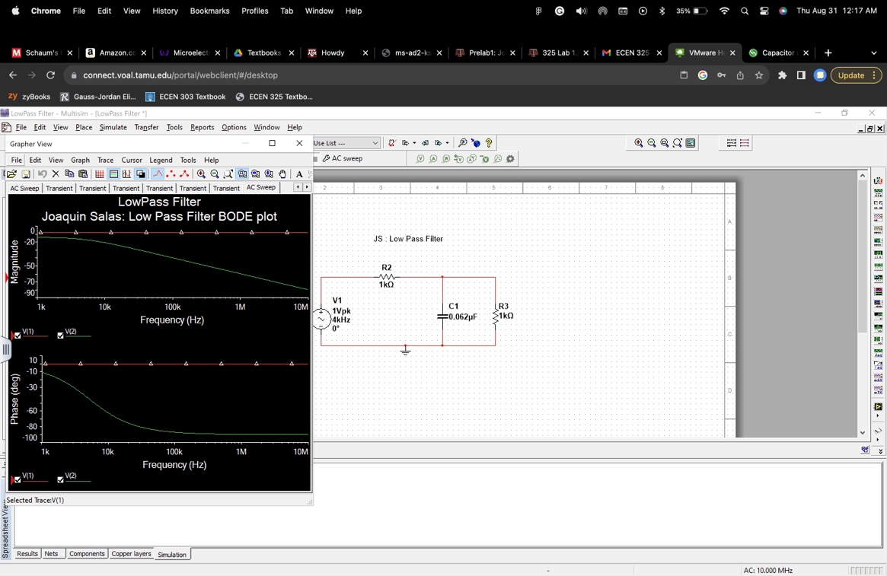

- Low Pass Filter Bode Plot at 6kHz and 3mV.

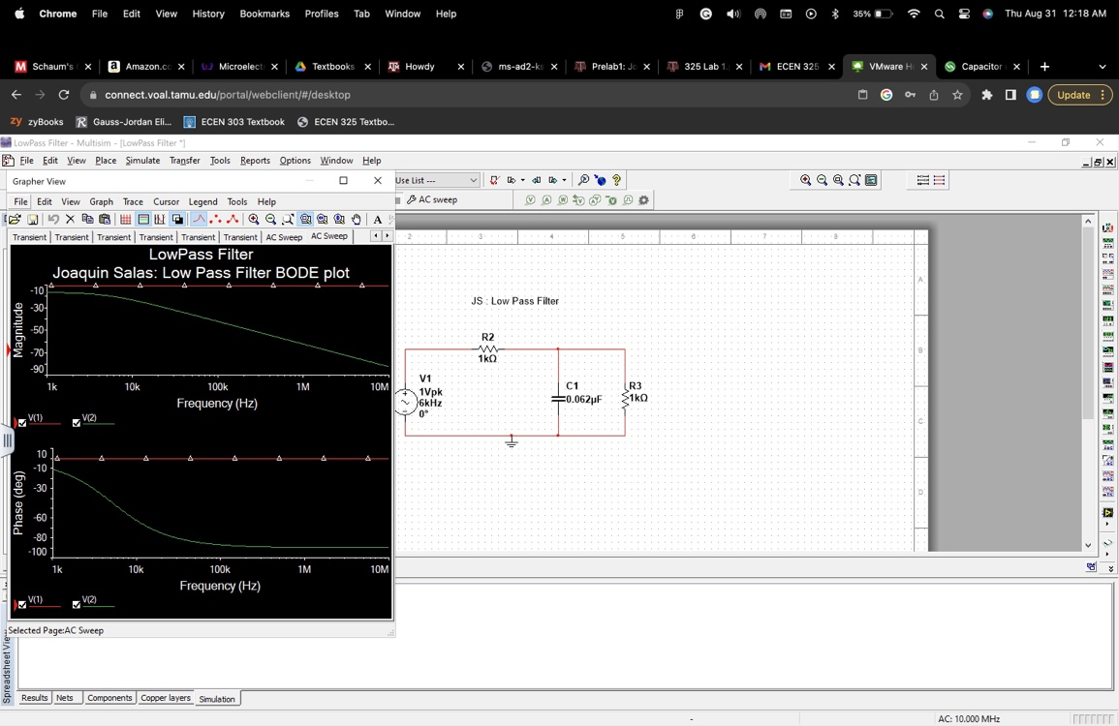

- Low Pass Filter Waveform Graph at 4kHz and 4mV.

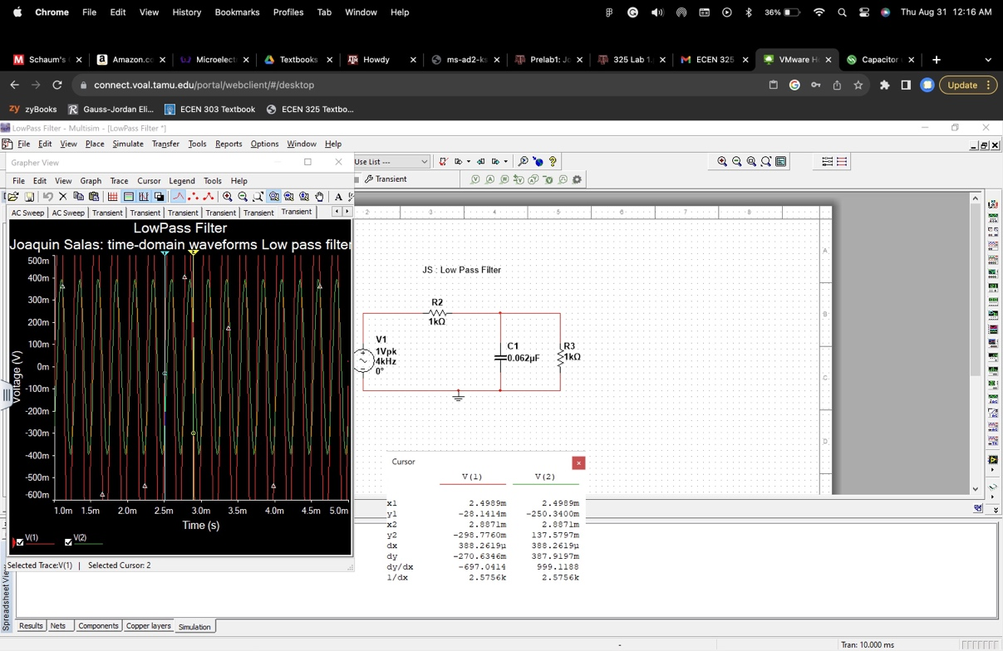

- Low Pass Filter Waveform Graph at 6kHz and 3mV.

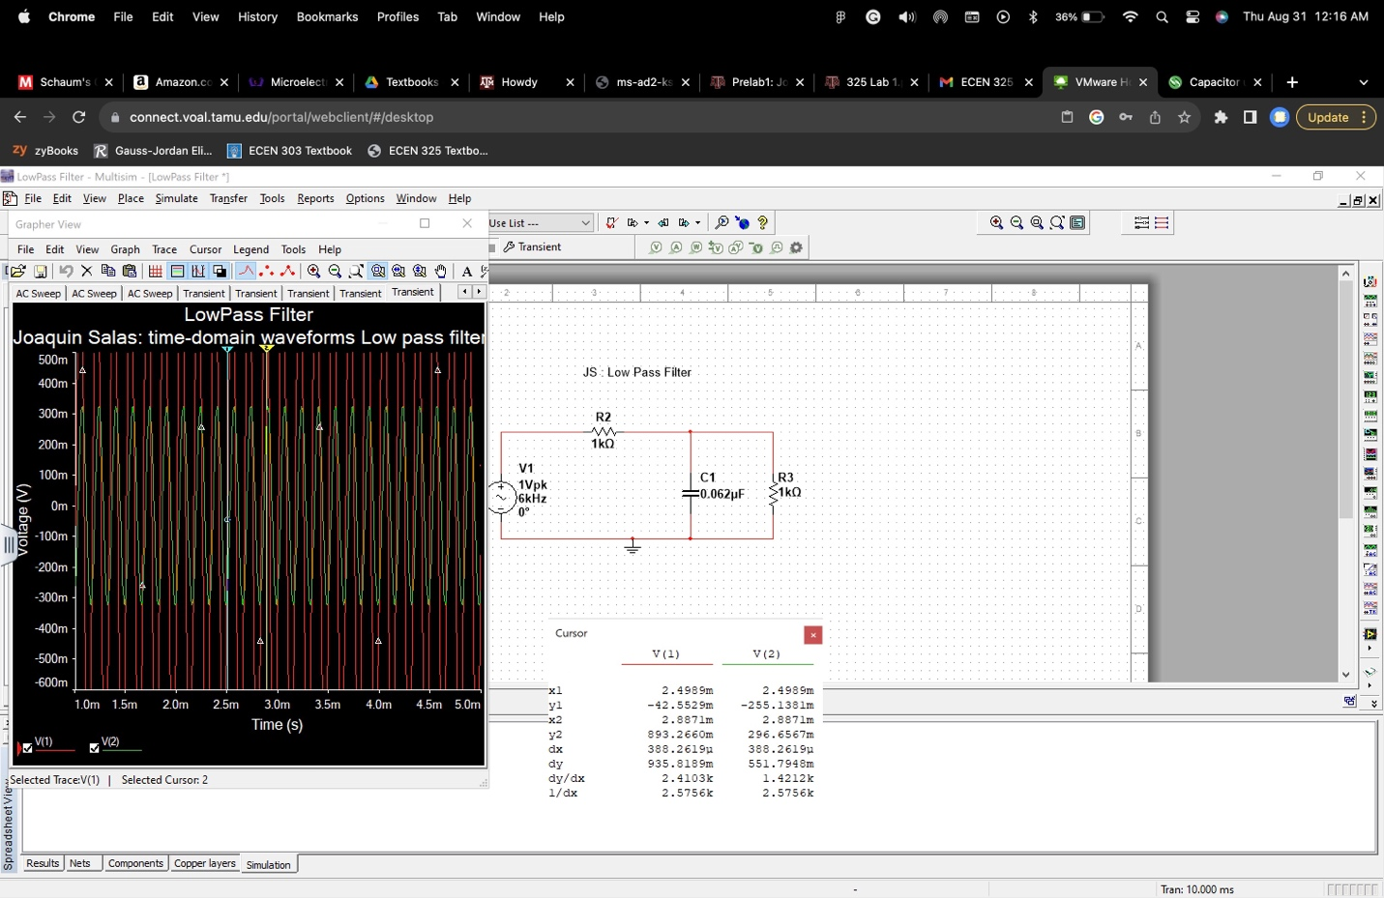

- High Pass Filter Bode Plot at 4kHz and 4mV.

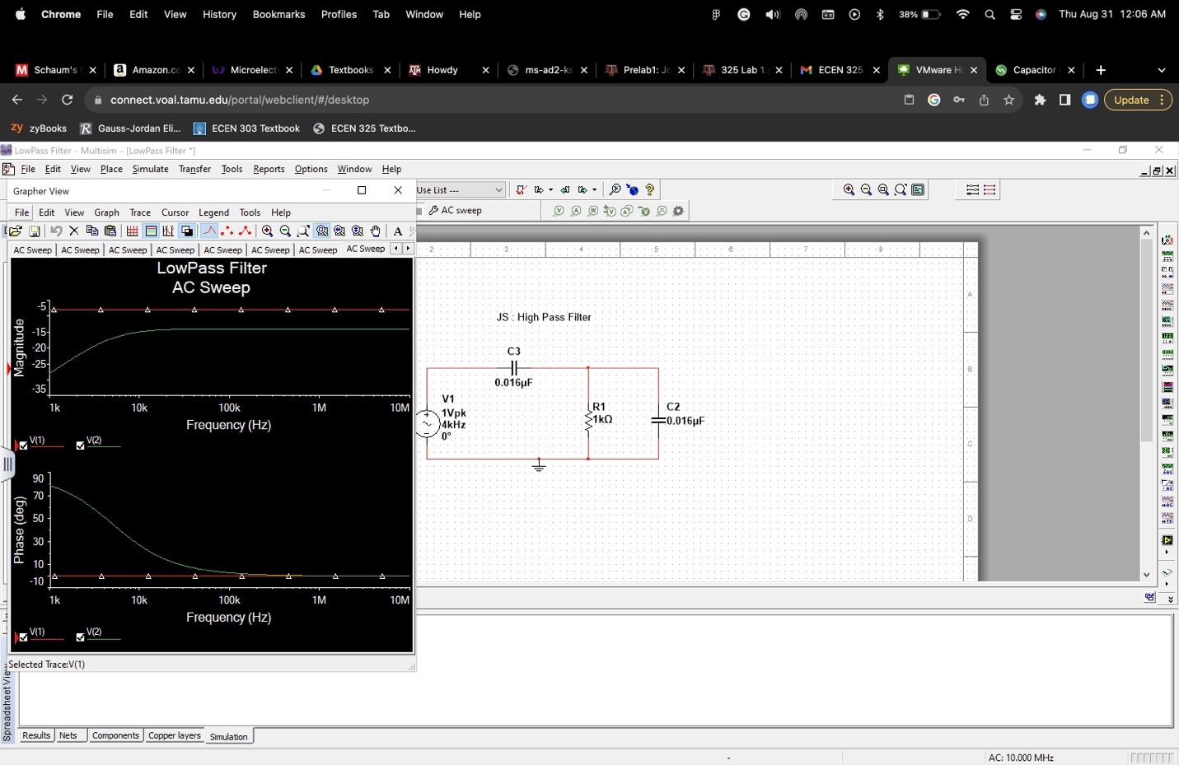

- High Pass Filter Bode Plot at 6kHz and 3mV.

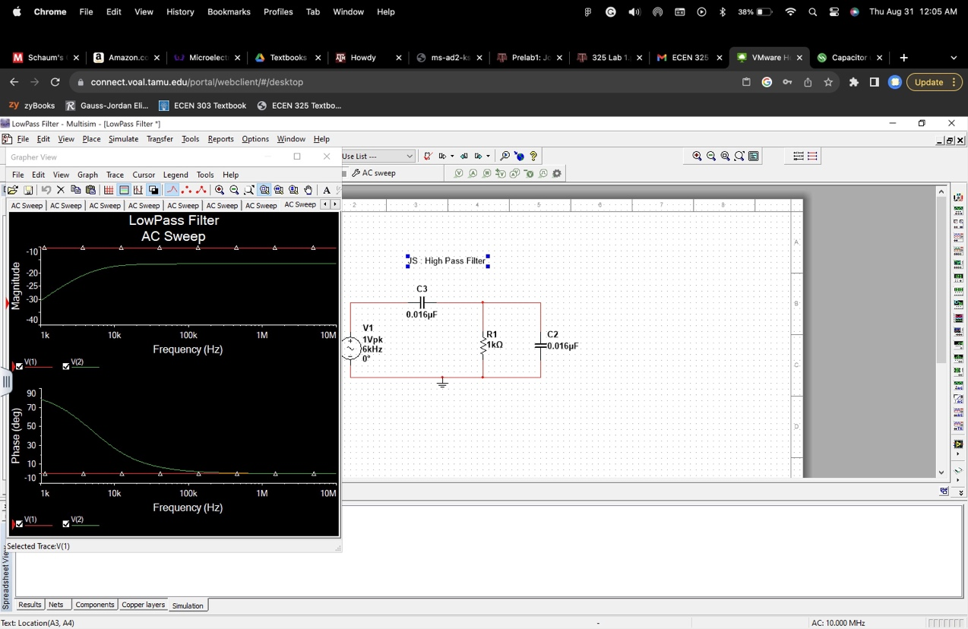
- High Pass Filter Waveform Graph at 6kHz and 3mV.

